Summerhill Services Gender Pay Gap Analysis
- 5^{th of} April 2025

Author: Katharine Thompson, Head of Human Resources

Contents
Introduction …………………………………………………………………………………………………………………………………….3
Gender Pay Gap ………………….…………………………………………………………………………………………………………4
Bonus Gender Pay Gap……………………………………………………………………………………………………………….5
Employee by Pay Quartile ………………………………………………………………………………………………..……….5
Make up of workforce ………………………………………………………………………………………………………………...6
Action to Date ………………………………………………………………………………………………………………………..……..6
Moving Forward………………………………………………………………………………………………………………………..……7
Conclusion……………………………………………………………………………………………………………………………………..…8

  - Introduction

  - Summerhill Services Limited (SSL) is a wholly owned subsidiary of Birmingham and Solihull Mental Health NHS Foundation Trust (BSMHFT) and provides a range of services, from Facilities Management Services to PFI Contract Management, to Transport Services and more.
  - This will be the sixth time that SSL has been required to submit a Gender Pay Gap report. This is because of staffing numbers growing from 366 (April 2024) to 383 as of the 5^{th of} April 2025.
  - The Equality Act 2010 (Specific Duties and Public Authorities) Regulations 2017 require public bodies with 250 or more employees on the snapshot date of 5th April of any given year to report their gender pay gap.
  - It is important to note that the gender pay gap is different to equal pay.
  - Equal pay deals with pay differences between men and women who carry out the same jobs, similar jobs, or work of equal value. It is unlawful to pay people unequally because they are a man or a woman.
  - The gender pay gap shows the difference between the average (mean or median) earnings of men and women. It is expressed as a percentage of men’s earnings.
  - A positive percentage figure reveals that typically, or overall, females have lower pay or bonuses than male employees. Whereas a negative figure reveals that males have lower pay or bonuses. Albeit unlikely, a zero-percentage figure would indicate no gap between the pay or bonuses of typical male and female employees.
  - The latest figures published by the Office of National Statistics (ONS)1 show that the median gender pay gap for all employees (both full and part-time) in April 2025 stood at 12.8% with SSL’s pay gap being 2.98% which is considerably below the average.
  - In April 2025, the gender pay gap was highest in skilled trades occupations and lowest in the caring, leisure and other service occupations.
  - This gender pay gap exists because women tend to work in lower-paid occupations and sectors and occupy fewer senior roles. Many women take time out of the labour market and work part-time because of unequal sharing of care responsibilities. Stereotypes and workplace culture are also factors.
  - Used to its full potential, gender pay gap reporting is a valuable tool for assessing levels of equality in the workplace, female and male participation, and how talent is being maximised.
1.11 The regulations require that the following calculations are completed:
- The mean gender pay gap.
- The median gender pay gap.
- The mean bonus gender pay gap.
- The median bonus gender pay gap.
- The proportion of males receiving bonus payment.
- The proportion of females receiving a bonus payment.
- The proportion of males and females in each quartile pay band.
1.12 The calculations make use of two types of averages:
- The mean, commonly known as the average, is calculated when you add up the wages of all employees and divide the figure by the number of employees. The mean gender pay gap is the difference between mean male pay and mean female pay. For example, if the

- hourly gender pay gap at a company is 32%, then for every £100 earned by a man a woman would earn £68.
- The median is the figure that falls in the middle of a range when everyone’s wages are lined up from smallest to largest. The median gap is the difference between the employee in the middle of the range of male wages and the middle employee in the range of female wages.
  - The median is typically a more representative figure as the mean can be skewed by outlying figures. A large difference between the mean and the median can be indicative of inequality at either end of the pay spectrum.
  - The results from the above calculations must be displayed on SSL’s website and be maintained for a minimum of three years, although SSL could decide to maintain it for longer than this in order to demonstrate long-term progress.
  - This report sets out the above calculations as at the snapshot date of 5th April 2025. In line with SSL’s ongoing commitment to equality.
  - The full dataset of full-pay relevant employees totalled of these being male and female.
2. Gender Pay Gap and Pay Quartiles
2.1 The overall gender pay gap figures show that a mean gap was calculated, alongside a median of 2.9835 which is a decrease from 2024 of 5.1131 this is a considerable decrease from the previous year. The headline figures are displayed in ‘Figure 1’ below:
Gender | Avg. Hourly Rate 2023 | Median Hourly Rate 2023 | Avg. Hourly Rate 2024 | Median Hourly Rate 2024 | Avg. Hourly Rate 2025 | Median Hourly Rate 2025
Male | 16.3334 | 13.1218 | 16.8625 | 14.0266 | 17.65 | 13.97
Female | 12.8889 | 12.1961 | 14.0372 | 12.8909 | 14.76 | 13.55
Difference | 3.4445 | 0.9257 | 2.8253 | 1.1357 | 2.9045 | 0.4169
Pay Gap % | 21.0889 | 7.0547 | 16.7552 | 8.0966 | 16.4550 | 2.9835

Figure 1
3. Bonus Gender Pay Gap
3.1 Bonuses, as defined by the regulations, include anything that relates to profit sharing, productivity, performance, incentive, and commission. They can be received in the form of cash, vouchers, securities, securities options, and interests in securities. Nonconsolidated bonuses are included.
3.2 As SSL is a wholly owned subsidiary of Birmingham and Solihull Mental Health NHS Foundation Trust (BSMHFT) it does not award bonuses to its employees. This is to ensure best value is provided to the NHS for the services it provides.
Quartile | Female % 2023 | Male % 2023 | Female % 2024 | Male % 2024 | Female % 2025 | Male % 2025
Lower Hourly Pay Quarter 1 | 67.61 | 32.39 | 54.95 | 45.05 | 62.11 | 37.89
Lower Middle Hourly Pay Quarter 2 | 65.00 | 35.00 | 72.83 | 27.17 | 56.25 | 43.75
Upper Middle Hourly Pay Quarter 3 | 72.09 | 27.91 | 63.74 | 36.26 | 63.54 | 36.46
Upper Hourly Pay Quartile 4 | 39.53 | 60.47 | 43.48 | 56.52 | 41.67 | 58.33
4. Employee by Pay Quartile

4.1 As part of the gender pay gap reporting, SSL must show the percentage of men and women ‘full pay relevant employees’ in four equal sized groups of employees based on their hourly pay as demonstrated in Figure 2.
Figure 2

5. Makeup of Workforce and impact on Gender Pay Gap
5.1 SSL is a Facilities Management company and due to the nature of its operations it employs a higher proportion of females (55.87%) to males (44.13%).
5.2 SSL Estates and Trade teams have a predominately male, ageing workforce. Across the facilities and construction sectors, organisations have struggled to attract females into the sector, and whilst this is changing, organisations need to positively promote these opportunities to females.
5.3 SSL has positively worked to encourage more males into domestic and housekeepers’ roles, to ensure a balance across the workforce, which is represented by a stabilization in the percentage of male employees to 37.89% within the lower hourly pay quarter.
  - SSL has also positively encouraged its workforce over the previous 12 months to undertake apprentice schemes and enhance their skills. SSL has actively worked hard through recruitment fairs and working with charities to reduce the age profile of its workforce and encourage more females into supervisory and management positions which is reflected in the current gender pay gap figures which show 63.54% of women within the upper middle hourly pay quartile and 41.67% within the upper quartile.

6. Action Taken to Date
6.1 SSL is an inclusive and diverse Company and aims to be representative of the communities we serve at all levels within the organisation.
6.2 The Company positively encourages and promotes flexible working wherever possible for all its colleagues. Hybrid working is offered to all non-front-line workforce at all grades. SSL positively attracts a high number of part time workers into its role across all sites within its Hotel Services and Catering departments.
6.3 SSL actively utilises EDI statistics and pay information to make informed decisions in relation to how it can reduce its gender pay gap and also improve diversity.
6.4 SSL benchmarks all roles and salaries with the external market utilising pay bench marking tool Cendex. This is to ensure that the role salaries offered, were aligned to the external market between the lower and median range. Where roles were not aligned, adjustments were made to both female and males to bring them in line with the lower quarter as a minimum in March 2024. SSL also compared salaries of male and female employees across grades to ensure these are aligned based on performance of the employee.
6.5 SSL has also positively encouraged its work force through 2025 to participate in additional training utilising both the Apprentice Levy and internal training to upskill their employees. This has resulted in more females being recruited to supervisory and management positions which is reflected in the female numbers which you see within the upper middle quartile and upper quartile.
6.7 Through a robust appraisal and a regular check-in process, colleagues can request and obtain training to support their professional development and growth with SSL.
6.8 SSL has launched its Graduate Program and has also commenced recruiting individuals for higher level Apprentice program NVQ Level 4 and above, as well as encouraging its existing workforce to complete higher level degree and masters programs. This has resulted in SSL recruiting more females and ethnic minorities into positions whereby they will become Managers for the future.

6.9 SSL has also commenced recruited Trade entry level Apprentices. through utilising positive female imagery within it’s adverts, it attracting females to apply and has appointed.
6.10 SSL in 2025 also launched its future program which has 6 strands to encourage employees to take responsibility for their development and support them to grown being Authentic Leadership, Graduates, Apprentices, Skilled Contributors, Talent Pipeline, and Managers Excellence, and is actively supporting all employees development and internal movement.
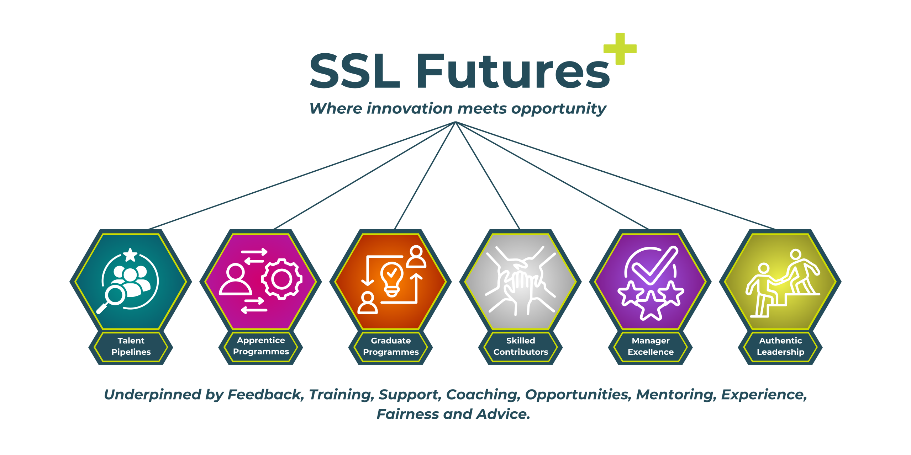

Moving Forward

7.1 Moving forward into 2024/2025 SSL will be revising its new pay policies for all SSL graded staff on SSL terms and conditions of employment, so that employees understand SSL’s pay structure and how their salaries are reviewed. It will continue to benchmark salaries on an annual basis to ensure SSL continues to align with the external market and their desire to pay all employees between the lower and median quartile.

7.2 SSL moving forward, will continue to look to utilise its Apprentice levy to attract females into the workforce by:

- Working with local colleges to attract females into trade apprentices from its internal talent pool and attracting external candidates.
- Working with universities to attract females into higher professional apprentice programs from its internal talent pool and attracting external candidates.

7.3 SSL will also look to develop further its Graduate program to attract early years talent with the support of EY, Leadership and Training Manager into Graduate positions and providing a glide path which develops leaders for the future.

7.3 SSL in 2025 will actively identify talent pools across all levels within the organisation, and will support its talent population through its future program to encourage further diversity is achieved within its middle management positions, who will grow with the organization to become Senior Managers of the future, focusing on actively encouraging candidates from an ethnic minority and female background.
8.0 Conclusion
8.1 SSL is committed to reducing further the gender pay gap across its workforce and increasing its diversity at all levels.
8.2 Working with its internal EDI forum, SSL will refresh its EDI Framework k ensuring that we are actively working towards being truly representative of the community we serve at all levels and that we narrow our Gender Pay Gap. Further to this will be the development of a ‘Diversity Action Plan’ which will address the gender and diversity pay gap actively over the coming years.
Kath Thompson
Head of HR

